Software Requirements Specification

for

A Customer Service Representative’s Software System

Prepared by Yusef Mohammed Hasan

Team members:

1. Yusef Mohammed Hasan (team leader). Code: 20235136
2. Yahia Mohammed Code: 20235131
3. Yusef Kamal Code: 20235135
4. Ahmed Mohammed Imam Code: 20235009

Table of Contents

Table of Contents ii

1. Introduction 1

1.1 Purpose 1

1.2 Project Scope 1

2. Overall Description 1

2.1 Product Features 1

2.2 User Classes and Characteristics 2

2.3 Operating Environment 2

2.4 Design and Implementation Constraints 3

3. System Features 4

3.1 The Host 4

3.1.1 Description 4

3.1.2 Stimulus/Response Sequences 4

3.1.3 Functional Requirements 4

3.2 Web Browser 5

3.2.1 Description 5

3.2.2 Stimulus/Response Sequences 5

3.2.3 Functional Requirements 6

3.3 Calls Manager 6

3.3.1 Description 6

3.3.2 Stimulus/Response Sequences 6

3.3.3 Functional requirements 7

3.4 Employee Management System 7

3.4.1 Description 7

3.4.2 Stimulus/Response Sequences 7

3.4.3 Functional Requirements 8

3.5 Employee Analysis System 9

3.5.1 Description 9

3.5.2 Stimulus/Response Sequences 10

3.5.3 Functional Requirements 10

3.6 Request Validation Software 10

3.6.1 Description 10

3.6.2 Stimulus/Response Sequences 10

3.6.3 Functional Requirements 11

3.7 Customer Accounts Manager 11

3.7.1 Description 11

3.7.2 Stimulus/Response sequence 12

3.7.3 Functional Requirements 12

3.8 Databases 13

3.8.1 Employee Database 13

3.8.2 Customers Database 16

3.8.3 Calls database 19

4. Nonfunctional Requirements 20

4.1 Performance Requirements 20

4.2 Security Requirements 20

Glossary 21

# Introduction

## Purpose

This document is an SRS document for a customer service representatives’ software system (CSRS); it contains a top-level description of this system alone, and other connections to outside systems will be briefly described. Other sub systems and the super system will be described in detail in other SRS documents.

## Project Scope

The software system is meant to be used by the customer service representatives and managers in the company. It is meant to help them process the requests through the phone calls quickly and easily to ensure customer satisfaction and loyalty. It is also meant to give the representatives a straight-forward GUI to help the representative make the right decisions and ensure great user experience.

# Overall Description

## Product Features

The major functions of the system are answering calls, accessing and manipulating the data inside the accounts database within certain constraints, and being able to access a selected dataset in the employee database. The blue-bordered area as seen in figure 1 is the sub-system that is directly accessible to the customer service representative. The software and entities outside of this border are meant to be indirectly accessible or completely inaccessible by the representative; for example, the representative should not be able to access the employee analysis system (EAS) in any way to ensure security over employee judgement and privacy.

## User Classes and Characteristics

Primary users of this system are customer service representatives from any department. The system can be a general template for how similar systems should behave. They are assumed to have completed high school education. They should also be aware of how to use a desktop computer as a prerequisite to training on using the system.

Other users include management, supervisors, and trainers who access the administrative and managerial parts of the system such as the EAS and the EMS.

## Operating Environment

The system is deployed on remote servers and is accessible via web browsers installed on desktop computers in the user’s workplace. The operating system that the computers will run is Windows 11 Enterprise. Notice that the web browser is the center piece of the entire system as shown in Figure 1.

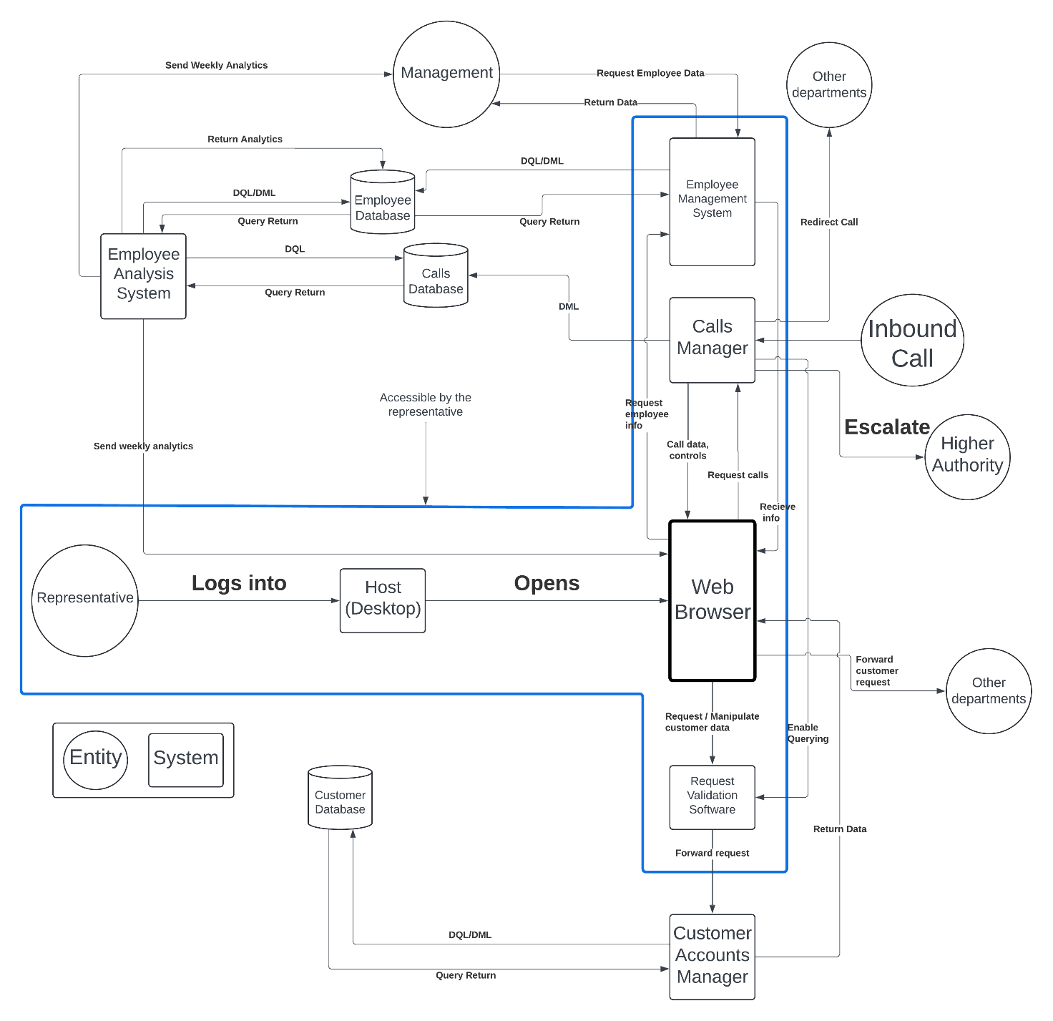

Figure : CSRS Diagram

## Design and Implementation Constraints

* The system will be deployed on remote servers.
* The user’s computer is a Windows 11 machine.
* A browser must be installed on the computer.
* The DBMS integrated into the system will be Microsoft SQL Server
* The calls will be forwarded to the user by remote servers using VoIP.

# System Features

The following illustrates the functional requirements for the product per system feature and the major services provided by the product.

## The Host

*Everything stated within this section and similar sections will be a top-level description.*

### Description

A desktop computer capable of running windows 11 Enterprise with a browser installed.

### Stimulus/Response Sequences

N/A

### Functional Requirements

1. Processor: 1 GHz or faster, with at least 2 cores on a compatible 64-bit processor or System on a Chip (SoC). The processor must be on Microsoft's list of approved CPUs for Windows 11.
2. RAM: 4 GB or more.
3. Storage 64 GB or larger storage device with added capabilities to use DirectStorage Which are an NVMe SSD for storage and a DirectX 12 GPU with Shader Model 6.0 support.
4. System Firmware: UEFI, with Secure Boot capability
5. TPM: Trusted Platform Module (TPM) version 2.0 is required.
6. Graphics Card: DirectX 12 compatible with a WDDM 2.0 driver.
7. Display: High-definition (720p) display, with a diagonal size greater than 9 inches, and 8 bits per color channel.
8. Internet Connection and Microsoft Account: Internet connection required to perform updates and download and take advantage of some features.
9. A web browser

## Web Browser

*Everything stated within this section and similar sections will be a top-level description.*

### Description

A web browser used as a user interface for using the system. The user can then send requests to other components and the returns will be structured and displayed on the screen.

### Stimulus/Response Sequences

* The user will be able to click on buttons and icons that will enable them to perform actions like a query for the customer database or simply just answering calls.
* When the user interacts with the GUI, the browser sends requests to the other systems connected to it for data retrieval and manipulation in certain cases:
* If the user needs to change or view customer data, the browser sends the request to the RVS (Request Validation Software).
* If the user wants to view the contact data of other CSRs (Customer Service Representatives), the browser sends the request to the EMS.
* When the browser is opened and idle, it sends requests to the calls manager to start receiving calls.
* Finally, if the CSR needs to send a customer’s request to other departments in case of inter-departmental involvement, the user needs to send the details of the problem via the browser to relevant departments.

### Functional Requirements

1. User authentication.
2. Access to internal systems.
3. Ability to send requests to the software within the system.
4. Sending the customer’s request
5. Data integrity and synchronization
6. Real-time communication and notifications.

## Calls Manager

*Everything said within this section and similar sections will be a top-level description.*

### Description

The calls manager is a web application that allows the user to receive, accept, and redirect calls. It also provides the web browser the UI for the call which resembles the standard UI seen on the call screen on your phone for example. The manager can record calls for future employee assessment by the EAS. The calls manager has access to the calls database to log recorded calls. The user can escalate the call through the calls manager. The calls manager receives VoIP calls.

### Stimulus/Response Sequences

* When a customer dials the customer service number, the call is sent to remote servers, then it finally reaches the calls manager that the CSR accesses.
* When the user opens the browser, the calls manager auto-starts and sends requests to the remote servers to start accepting calls.
* When a call needs to be redirected, the user sends the request to the manager via the web browser and the calls manager manages the redirection.
* When a call starts, the manager starts recording the call.
* While the user is in the call, the manager sends a request to the Request Validation Software (RVS) which is placed between the Customers Accounts Manager (CAM) and the web browser to enable customer data manipulation using DML queries sent by the CAM.
* After the call is done, the manager logs the recorded call onto the database.

### Functional requirements

1. The manager MUST be able to receive, accept, redirect, and escalate calls.
2. The manager should only send queries to the calls database to add new calls.
3. The manager should be able to communicate with the RVS.

## Employee Management System

*Everything said within this section and similar sections will be a top-level description.*

### Description

The Employee Management System (EMS), as the name states, handles managing the employees within the entire company. From general employee data such as contact info to confidential data such as the employee’s assessment and salary.

The EMS is one of the most important systems within the company. Only one part of the system’s functions will be usable by the employees; CSRs will only be able to view other CSRs’ data such as their name, ID and contact info and they won’t be able to view work-related or performance info, while management has complete access to the system. The EMS is also an interface for the Employee Database.

### Stimulus/Response Sequences

* If the EMS receives requests from the CSR to view employee data, the EMS responds to the request with a selected part of the data from the EDB.
* The EMS Sends DQL Queries to retrieve the data from the EDB.
* If the EMS receives a request from management to manipulate or view an employee's data, the EMS sends a DML/DQL query to the EDB and returns the result to management.

### Functional Requirements

1. The EMS must only return the following columns in case of an employee’s query:
   * Employee name
   * Employee ID
   * Employee email
   * Employee phone number
2. The EMS must be able to return all columns about the employee data in case of a manager’s query.
3. Managers must have DML/DQL privileges.
4. Employees must have DQL privileges only.

## Employee Analysis System

*Everything said within this section and similar sections will be a top-level description.*

### Description

The Employee Analysis System (EAS) handles employee analysis and assessment. It calculates the following:

Quantitative scores:

* **Average Handle Time (AHT)**: Measures the time taken to complete customer interaction from start to finish.
* **First Call Resolution (FCR)**: The percentage of issues resolved on the first contact without needing follow-up.
* **Customer Satisfaction Score (CSAT)**: Directly measures customer satisfaction after an interaction, usually through a survey.
* **Net Promoter Score (NPS)**: Measures the likelihood of customers recommending the company.
* **Response Time**: The time it takes for a CSR to respond to a customer inquiry.
* **Service Level Agreements (SLA) Compliance**: Refers to how often CSRs meet predetermined standards for response and resolution times, as defined by the SLA.

Qualitative scores:

* **Quality Assurance (QA) Scores**: QA teams often evaluate a sample of interactions to ensure adherence to scripts, tone, empathy, and resolution quality.
* **Call Monitoring and Review**: Managers or QA specialists listen to recorded interactions and provide feedback on soft skills, adherence to company guidelines, and issue resolution approaches.

These assessments are typically combined to offer a comprehensive view of a CSR’s performance and can be used for training, rewards, and to identify top performers and those who may benefit from additional support.

### Stimulus/Response Sequences

* The EAS accesses the EDB and updates the employee assessment data with automated weekly analytics and assessments.
* It allows the performance analysts to access the calls database to review and assess the calls.
* Management and the employee have the privilege to view the weekly assessments.
* New weekly assessments and analytics get sent to management and the employee.

### Functional Requirements

1. Generate and Send Weekly Analytics.
2. Access and Query the Employee Database
3. Process and Return Analytics Data
4. Interface the Calls Database
5. Provide Accessible Analytics for Representatives

## Request Validation Software

*Everything said within this section and similar sections will be a top-level description.*

### Description

The Request Validation Software’s sole purpose is to validate the CSR’s request for accessing the CustDB.

### Stimulus/Response Sequences

* The RVS receives a request for access from the calls manager at the start of the call to allow the CSR to access the CustDB.
* The RVS validates this request and specifies a row for the CSR that contains the customer’s number on the call.
* From here, the CSR has direct access to the CAM where they can manipulate and view that row in the CustDB While the CAM acts as an interface.
* If the customer on the call does not exist in the database, the RVS will allow the user to access a special window provided by the CAM to create a new account and add a new row to the table in the customer database.

### Functional Requirements

1. receive the request from the Calls Manager
2. validate the request from the Calls Manager
3. Specify the row to be accessed and send its data to the CAM.
4. Open communications between the CSR and the CAM

## Customer Accounts Manager

*Everything said within this section and similar sections will be a top-level description.*

### Description

The Customer Accounts Manager (CAM) is a web application which’s role is to provide a GUI for the CSR to access and manipulate the database.

The CAM can add, update, and delete information from the Customer Database by translating the buttons clicked and data typed in fields into SQL queries that the DBMS would execute.

### Stimulus/Response sequence

* The Customer Accounts Manager receives the request that the representative has sent, after it has been validated by the Request Validation Software.
* The Customer Accounts Manager then accesses the Customer Database specifically the row that the RVS specifies (if the row exists).
* The Customer Accounts Manager proceeds to show the user the existing data in the table in fields in the GUI.
* The CSR can then confirm the changes which will prompt the CAM to execute SQL queries on the database and the data will be changed.
* After the query is executed, the CAM returns a confirmation message to the CSR along with the modified account (row).

### Functional Requirements

* Receive CSR requests via RVS
* Act as an interface between the representative and the Customers database
* Complete Access to the Customers database*
* Generate and execute DML/DQL SQL queries
* Send the data to the web browser

*While the CAM has complete access to the database, the CSR doesn’t have complete access to the database.

## Databases

### Employee Database

#### Employee Personalia table

|  |  |
| --- | --- |
| Column | Data Type |
| Employee_id | INTEGER (Primary Key) |
| First_name | VARCHAR(20) |

|  |  |
| --- | --- |
| Last_name | VARCHAR(20) |
| Password_hash | VARCHAR(100) |
| Gender | CHAR |

|  |  |
| --- | --- |
| email | VARCHAR(100) |

|  |  |
| --- | --- |
| Address | VARCHAR(100) |

|  |  |
| --- | --- |
| Phone_number | VARCHAR(20) |

|  |  |
| --- | --- |
| Date_of_birth | DATE |
| Department | VARCHAR |
| Department_id | INTEGER (Foreign Key) |

#### Department Table

|  |  |
| --- | --- |
| Column | Data Type |
| Department_name | VARCHAR(100) |
| Department_id | INTEGER (Primary Key) |
| Manager_id | INTEGER (Foreign Key) |

#### Attendance Table

|  |  |
| --- | --- |
| Column | Data Type |
| Employee_id | INTEGER (Foreign Key) |
| Date | DATE |
| Check_in | TIME |
| Check_out | TIME |

#### Payroll Table

|  |  |
| --- | --- |
| Column | Data Type |
| Employee_id | INTEGER (Foreign Key) |
| Pay_date | DATE |
| Base_salary | DOUBLE(7,2) |
| bonuses | DOUBLE(7,2) |
| deductions | DOUBLE(7,2) |
| Net_pay | DOUBLE(7,2) |

#### Employee Performance table

|  |  |
| --- | --- |
| Column | Data Type |
| employee_id | INTEGER (Foreign Key) |
| Average_Handle_Time(AHT) | Float (minutes) |
| First_Call _Resolution(FCR) | Float (percentage) |
| Customer_Satisfaction_Score(CSAT) | Float (percentage) |
| Net_Promoter_Score(NPS) | Integer |
| Response_Time | Float (seconds) |
| SLA_Compliance | Float (percentage) |
| Quality_Assurance_Scores | Float (score) |
| QA_Comments | VARCHAR |

### Customers Database

#### Customer personalia

|  |  |  |
| --- | --- | --- |
| Column | Data Type | Description |
| Cust_ID | INTEGER (Primary Key) | Unique identifier for each customer |
| First_name | VARCHAR(20) | The first name of the customer |
| Last_name | VARCHAR(20) | The last name of the customer |
| Gender | CHAR | The Customer’s gender |
| Date_of_birth | DATE | N/A |
| Phone_number | VARCHAR(12) | N/A |
| email | VARCHAR(50) | The Customer’s email |

#### Accounts table

|  |  |  |
| --- | --- | --- |
| Column | Data type | Description |
| Account_ID | INTEGER (PK) | Unique identifier for each customer account |
| Cust_ID | INTEGER (FK) | Links to the Customers table to associate the account with a specific customer |
| Account_Type | VARCHAR(20) | Indicates the type of account (e.g., Individual, Business) |
| Status | ENUM('Active', 'Inactive') | Represents the status of the account |
| Date_Opened | DATETIME | Timestamp indicating when the account was opened |
| Date_Closed | DATETIME | Timestamp indicating when the account was closed (nullable, for active accounts). |

#### Subscriptions table

|  |  |  |
| --- | --- | --- |
| Column | Data Type | Description |
| subscription_id | INTEGER (PK) | Unique identifier for each subscription |
| account_id | INTEGER(FK) | Unique identifier for each account |
| service_type | VARCHAR(20) | The type of service the subscription provides (e.g., Mobile, Internet, TV) |
| plan_name | VARCHAR(20) | The name of the plan the customer is subscribed to |
| plan_details | VARCHAR | The details of the plan provided by the business |
| Start_date | DATE | N/A |
| End_date (for terminated services) | DATE | N/A |
| status | ENUM('Active', 'Ended') | Whether the subscription is still active |

### Calls database

#### Calls metadata

|  |  |  |
| --- | --- | --- |
| Column | Data Type | Description |
| Call_ID | INT (Primary Key) | Unique identifier for each call record |
| Customer_ID | INT | Links to the Customers table to associate the call with a specific customer |
| Call_date | DATE | The day the call was recorded |
| CallStartTime | TIME | Timestamp indicating when the call started |
| CallEndTime | TIME | Timestamp indicating when the call ended |
| Duration | INT (seconds) | Duration of the call in seconds |
| Direction | ENUM('Incoming', 'Outgoing') | Indicates whether the call was incoming or outgoing |
| Summary | TEXT | Summary of the call's content or purpose |
| Notes | VARCHAR | Notes related to the call |

#### Call URL

|  |  |  |
| --- | --- | --- |
| Column | Data Type | Description |
| Call_id | INTEGER (PK) | Unique identifier for each call recorded |
| File_path* | VARCHAR | The path to the recording |

*The recorded calls will be stored on large storage devices and the file_path points to its location on the storage device.

# Nonfunctional Requirements

## Performance Requirements

* The UI must be responsive and communication between every software component active during the call must be fast to ensure customer and user satisfaction.
* Refer to 3.1.3 to review the minimum hardware requirements for a Windows 11 machine. Better hardware components contribute to better overall performance.

## Security Requirements

* The calls must be secure, and the primary user (CSR) must not be able to directly access the area beyond the blue border, especially the EAS.
* The only part of the EMS that will be accessible by the CSR is DQL querying on the Employee Personalia table to give them the ability to find other coworkers’ contact info.
* The RVS is a functional security requirement due to the company’s policies.
* The customer database will be partly accessible during the call; the row containing the customer number will accept changes.
* Management is completely privileged to view and manipulate the employee database through the employee management system. They also have access to the EAS.
* The recorded calls need to be stored in secure storage systems only accessible through the EAS

Glossary

* CAM: Customer Accounts Manager.
* CDB: Calls Database.
* CSR: Customer Service Representative.
* CSRS: Customer Service Representative System.
* CustDB: Customer Database.
* DBMS: Database Management System.
* EAS: Employee Analysis System
* EDB: Employee Database.
* EMS: Employee Management System.
* GUI: Graphical User Interface
* RVS: Request Validation Software.